**Name………………………………………………… Admission No…………………………………..**

**Student’s signature…………………………. Date…………….…………………………….…..**

**FANAKA GIRLS HIGH SCHOOL**

**DECEMBER HOLYDAY ASSIGNMENT**

**TOTAL:**

**CHEMISTRY**

**FORM 2**

**2hours**

**INSTRUCTIONS TO STUDENTS**

1. **Write your name and admission number in the spaces provided above.**
2. **Answer all the questions in this question paper.**
3. Carbon (IV) oxide is one gases used in fire extinguisher.
4. State any other possible use of carbon (IV) oxide (1mrk)

1. Name two reagents that can be reacted to generate carbon (IV) oxide (2mrks)
2. a) What is rust (1mrk)

b) State 2 conditions that accelerates rusting (2mrks)

c) State one advantage of rusting (1mrk)

1. Name three mineral acids commonly in chemistry laboratory (3mrks)
2. Using dots and crosses, show the bonding in carbon II oxides (2mrks)
3. a) Aluminum is a better conductor of electricity than magnesium. Explain (2mrks)

b) State one use of aluminum (1mrk)

1. A beekeeper found that when stung by a bee, application of a little solution of sodium hydrogen carbonate helped to relieve the irritation from the affected area. Explain (2mrks)
2. The diagram below shows a jiko when in use. Study it and answer the question that follow

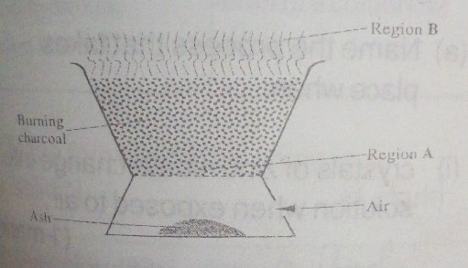

1. Identify the gas formed at region A (1mrk)
2. State and explain the observation made at region B (2mrk)
3. In a laboratory experiment hydrogen gas was passed over heated copper (II)oxide as shown on the diagram below

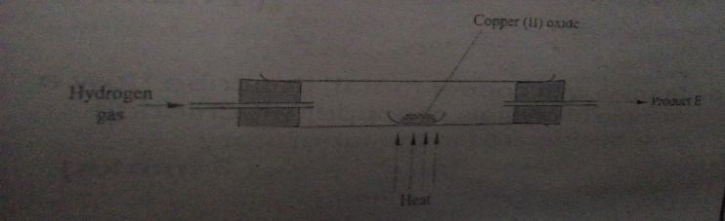

Describe the chemical test that can be used to identify the product E (2mrk)

1. State 2 uses of diamond (2mrk)
2. Define the following terms (3mrks)
3. An element
4. An atom
5. Compound
6. When iodine was heated, it changed directly from solid to gaseous state.
   * 1. Give the name of the process above (1mrk)
     2. State any other two substances that undergo the process above (2mrks)
7. Name three acid base indicator found in the chemistry laboratory (3mrks)
8. Complete the following chemical equation and balance them (4mrks)

Cu (s) + HNO3 (aq)

MgO (S) + H2SO4 (aq)

1. What name is given to: (3mrks)
2. Group I elements
3. Group II elements
4. Group vii elements
5. Explain why carbon (II) oxide is poisonous (2mrks)
6. Give a reason why the reaction between barium carbonate and dilute sulphuric acid stop immediately

(1mrk)

1. Use the grid below to answer the question that follow. Letter do not represent the actual symbol of the elements.

|  |  |  |  |  |  |  |  |  |
| --- | --- | --- | --- | --- | --- | --- | --- | --- |
|  |  |  |  |  |  |  |  |  |
| F |  |  |  |  |  | O |  |
| G | J |  | K | L | N | P | Q |
| H |  |  |  |  |  |  |  |

1. What family name is given to element G and H (1mrk)
2. State and explain the difference in reactivity between (3mks)
   * 1. G and J
     2. N and P
3. How does the atomic radius of K compared to that of L. Explain (2mks)
4. Element R forms an oxide of the formula RO2 and belong to period 2. Indicate in the grid

the position of R (1mrk)

1. Explain the trend in melting point in the group of elements to which I and J belong (2mrks)
2. Write the formula of the compound formed when K and P reacted (1mrk)
3. Name the type of bond formed when F reacted with O. explain (1 ½ mrks)
4. Give one use of element Q (1mrk)
5. Write down the electronic arrangement of an ion of: (1mrk)

H

N

1. Give three uses of hydrogen gas (3mrks)
2. Name 3 raw material used in the Solvay process (3mrks)
3. Why is potassium stored under paraffin (1mrk)
4. Name 3 apparatus that can be used to determine in the laboratory (3mrks)
5. Under what circumstance will graphite used as a lubricant instead of grease? Explain (2mrks)
6. During preparation of copper (II) sulphate excess copper (II) oxide us used. Explain (2mrks)
7. Write the chemical formula of TRONA (1mrk)
8. Use the diagram below to answer the question that follow

Wet trona dry trona

kiln

Z

washery

TRONA

Q

Bagging and storage

W HOT SODIUM

CARBONATE

Heat exchanger

1. Name the method used to mine trona (1mrk)
2. Name the following parts (2mks)

Z

Q

1. At what temperature is trona crystalizes and removed from the lake (1mrk)
2. Write the two chemical equation that take place in the kiln (4mrk)